**Fattah Samit**

**191-15-12876**

**Section K**

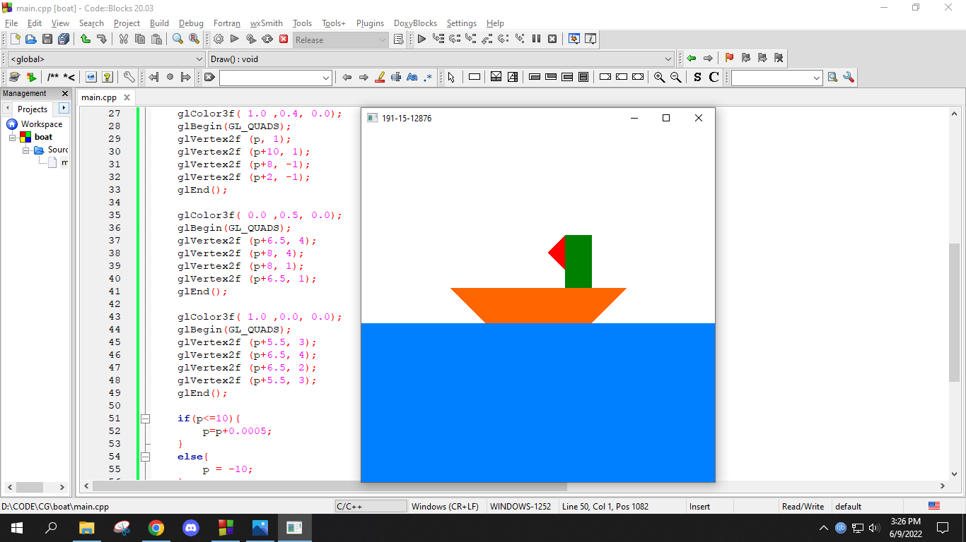

**Source Code:**

#include<windows.h>

#include <GL/glut.h>

#include <stdio.h>

#include <GL/gl.h>

float p = -10;

void init(void){

glClearColor(1.0,1.0,1.0,0.0);

glMatrixMode(GL_PROJECTION);

glLoadIdentity();

glOrtho(-10.0, 10.0, -10.0, 10.0, -10.0, 10.0);

//gluOrtho2D(0.0,300.0,0.0,300.0);

}

void Draw(){

glClear(GL_COLOR_BUFFER_BIT);

glColor3f( 0.0 ,0.5, 1.0);

glBegin(GL_POLYGON);

glVertex2f (-10, -1);

glVertex2f (10, -1);

glVertex2f (10, -10);

glVertex2f (-10, -10);

glEnd();

glColor3f( 1.0 ,0.4, 0.0);

glBegin(GL_QUADS);

glVertex2f (p, 1);

glVertex2f (p+10, 1);

glVertex2f (p+8, -1);

glVertex2f (p+2, -1);

glEnd();

glColor3f( 0.0 ,0.5, 0.0);

glBegin(GL_QUADS);

glVertex2f (p+6.5, 4);

glVertex2f (p+8, 4);

glVertex2f (p+8, 1);

glVertex2f (p+6.5, 1);

glEnd();

glColor3f( 1.0 ,0.0, 0.0);

glBegin(GL_QUADS);

glVertex2f (p+5.5, 3);

glVertex2f (p+6.5, 4);

glVertex2f (p+6.5, 2);

glVertex2f (p+5.5, 3);

glEnd();

if(p<=10){

p=p+0.0005;

}

else{

p = -10;

}

glutPostRedisplay();

glutSwapBuffers();

}

int main(int argc,char **argv){

glutInit(&argc,argv);

glutInitDisplayMode ( GLUT_RGB | GLUT_DOUBLE );

glutInitWindowPosition(0,0);

glutInitWindowSize(500,500);

glutCreateWindow("191-15-12876");

init();

glutDisplayFunc(Draw);

glutMainLoop();

return 0;

}